**WINAIM** - Screening Assignment - 2023 & 2024 YOP

**SQL Assessment**

**Exercise 1:** Employee Management System

**Objective:** To test the ability to design relational databases, write complex SQL queries, and handle data relationships.

**SQL Queries:**

1. Write a query to find all employees who have been hired in the last year.

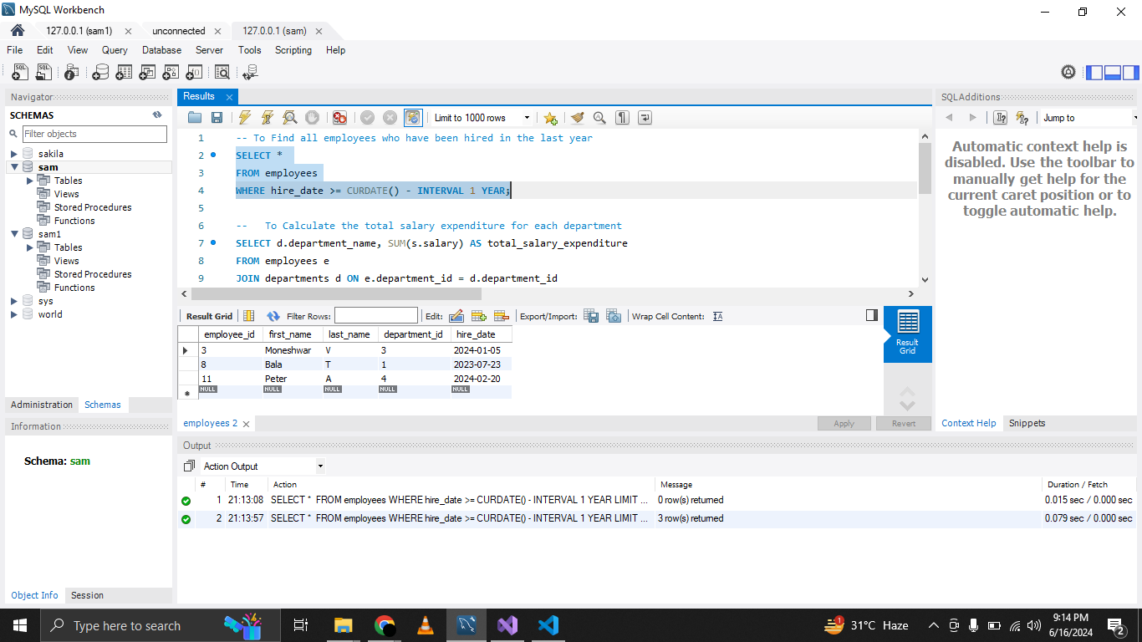

1. Write a query to calculate the total salary expenditure for each department.

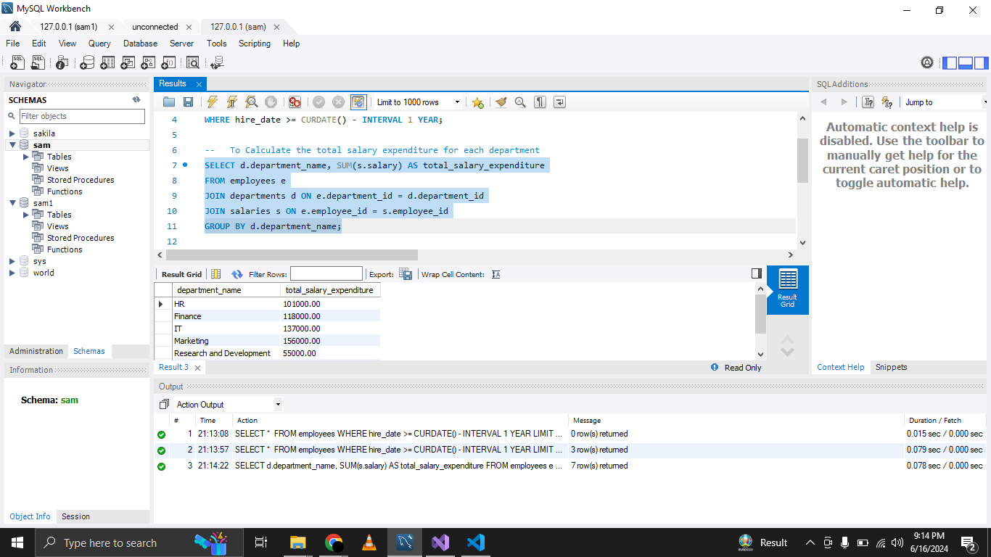

**3.** Write a query to find the top 5 highest-paid employees along with their

department names.

